MATH 115 QUIZ 2 July, 2017 Instructor: I. Izmirli

NAME: _______________________________

I have completed this assignment myself, working independently and not consulting anyone except the instructor.

INSTRUCTIONS
- The quiz is worth 100 points. There are 10 problems.
- Each problem is worth 10 points
- This quiz is open book and open notes. This means that you may refer to your textbook, notes, and online classroom materials, but you must work independently and may not consult anyone (and confirm this with your submission). You may take as much time as you wish, provided you turn in your quiz no later than Sunday, July 9.
- Show work/explanation. Answers without any work may earn little, if any, credit. You may type or write your work in your copy of the quiz, or if you prefer, create a document containing your work. Scanned work is acceptable also. In your document, be sure to include your name and the assertion of independence of work.
- General quiz tips and instructions for submitting work are posted in the Quizzes module.
- If you have any questions, please contact me by e-mail.

1. The note 'G' above the note 'middle C' is a sound wave with ordinary frequency f = 392 Hertz = 392 cycles/second. State a sinusoid which models this note, assuming that the amplitude is 1 and the phase shift is 0.

2. Solve the equation $\sin{(2x)}=\sqrt{2}\sin{(x)}$ , finding all solutions in the interval [0, 2π).
Show work. You should be able to provide the exact values of the solutions and state them in radians.

3. Solve the equation $3 arccos{(2x)}=2π$.

4. Solve the equation $\cos{(x)}\cot\left(x\right)+\sqrt{3}\cos{(x)}$ = 0, finding all solutions in the
interval [0, 360°).

5. For the triangle ABC, we are given that C = 65°, a = 16.0, and c = 24.0.
(Side a is the side opposite angle A, side b is the side opposite angle B, and side c is the side opposite angle C.)
Solve the triangle; that is, find the two remaining angles and the remaining side.
Report angles to the nearest degree and the length rounded to one decimal place.

6. In a pentagon each of the five exterior sides are 40 ft. long.
921 ft.
A
54°
54°
B
C

What is the distance from a vertex to the center of the pentagon? That is, what is the distance between A and C?

7. Two hikers leave the same tent at a campground and go separate ways. One hiker walks 9 miles directly south to Ashville, and the other hiker walks 15 miles directly northwest (i.e., N45°W) to Bellville. (Assume that the terrain is flat.) How far apart are Ashville and Bellville (by the most direct route)? Round your answer to the nearest tenth of a mile.

8. Let $\vec{v}$ = ⟨3, 1⟩ and $\vec{w}$ = ⟨2, – 4⟩.

(a) Which of the following graphs shows these two vectors? Choose I, II, III, or IV.
(I) | (II) | (III) | (IV)
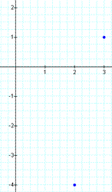 | 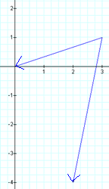 | 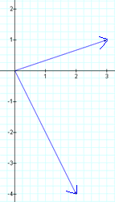 | 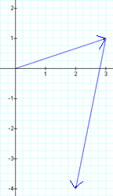

(b) Find 5$\vec{v}$ + 6$\vec{w}$ and state the result in component form.

9.
(a) Let $\vec{v}$ = ⟨-2, 7⟩ and $\vec{w}$ = ⟨6, – 4⟩. State the exact magnitude (length) of $\vec{v}$ and the exact magnitude of $\vec{w}$.

(b) State the dot product $\vec{v}$ ⋅ $\vec{w}$.

10. Let $\vec{v}$ = ⟨-2, 7⟩ and $\vec{w}$ = ⟨6, – 4⟩. Find ${proj}_{\vec{ w} }(\vec{v})$ in component form. Give exact values.

(f) Determine the angle between $\vec{v}$ and $\vec{w}$. Show work. Write the exact angle as the arccosine of an appropriate number. Also, use a calculator to approximate the value of the angle, rounding the result to the nearest degree.

